 | THE COMMONWEALTH OF MASSACHUSETTS  WATER RESOURCES COMMISSION

Water Resources Commission Decision
September 12, 2002

60 Research Road & 105 Research Road
(Also known as Sager Electronics & J.M. Perrone Co., Inc.)
Sewer Project
Hingham

Request for Determination of Insignificance
Under the Interbasin Transfer Act
MGL Chapter 21 Sections 8B-8D

Introduction

On January 8, 2002, the Massachusetts Water Resources Commission (WRC) received a request for determination of insignificance under the Interbasin Transfer Act (M.G.L. Chapter 21 §§ 8B-8D) from Sager Electronics and J.M. Perrone Co., Inc. for a proposed sewer connection to the MWRA wastewater system through the town of Weymouth’s sewer system. This request was discussed at the August 8, 2002 WRC meeting. At its September 12, 2002 meeting, the WRC voted unanimously of those present that the proposed sewer connection from 60 Research Road and 105 Research Road (the Sager Electronics and J.M. Perrone Co., Inc. properties) is insignificant under the Interbasin Transfer Act.

REASONS FOR THE WRC DECISION

The Sager Electronics and J.M. Perrone Co., Inc. properties are located within the town of Hingham and receive water supply from the Weymouth and Weir subbasin of the Boston Harbor basin. Wastewater is proposed to be discharged to the Massachusetts Coastal basin. The capacity of the original request was 55,000 gallons per day. After review of the application, it was suggested that the proponent redesign or otherwise decrease the ability of the project to transfer wastewater and resubmit the application for a lesser amount, as the original application did not meet the criteria for insignificance, as listed in the Interbasin Transfer Act regulations, 313 CMR 4.04(4).

On June 25, 2002, the additional information needed to evaluate this request at a lesser amount was received. The increase in interbasin transfer caused by these projects is 4,500 gallons per day. The ability to transfer wastewater flows under the new request will be governed by contracts with the Town of Weymouth and legislation authorizing the properties to be admitted into the MWRA Sewerage System.

Analysis of the Proposed Transfer

The Sager-Perrone Request for Determination of Insignificance was reviewed by Staff from DEM’s Office of Water Resources and DFWELE’s Riverways Program and Division of Marine Fisheries against the criteria for insignificance listed in the Interbasin Transfer Act regulations, 313 CMR 4.04(4).

Synopsis of Criteria for Insignificance

Criterion | Sager-Perrone’s Application
(a) Is not over 1 mgd | Meets
(b) Is less than 1 mgd on an annualized basis and is temporary, of short duration and for a purpose other than water supply use | Not applicable
(c) Additional flow is less than 5% of the instantaneous flow | Meets
(d) The 95% exceedance flow, or the 7Q10 flow when relied in a program of pollution abatement, will not be diminished | Meets
(e) Special resource values will not be adversely affected | Meets
(f) The Commission shall consider the cumulative impacts of all past, authorized or proposed transfers on streamflows in the donor basin | Meets

A description of how the application addressed these criteria is found below and in Attachment 1.

Streamflow/Hydrologic Impacts

Sager Electronics and J.M. Perrone Co., Inc. (Sager-Perrone), which are located in the headwaters of the Old Swamp River, are proposing to transfer wastewater from the Weymouth–Weir subbasin in the Boston Harbor Basin to the Massachusetts Coastal Basin. The proposed transfer of 0.0045 mgd would result from a connection to the Weymouth (MWRA) sewer system by the two companies, which are located in the Town of Hingham.

The companies currently receive their water from Aquarion (formerly the Massachusetts American Water Company) in Hingham. The water supply to the companies, which is proposed to be transferred as wastewater, comes from the Weir River Basin, which is not hydrologically connected to the Weymouth Back River Basin, of which the Old Swamp River is a tributary (Figure 1). Therefore, transfer of the water as proposed would result in a return to pre-development conditions.

The proponents were asked to evaluate the impacts to the streamflow criteria in the regulations. Criteria for determination of insignificance include: less than 5% of the instantaneous flow can be withdrawn (transferred) and the 95% exceedance flow or, the 7Q10 flow when used in a program of pollution abatement, will not be diminished.

Flow data from a nearby gage is usually used to evaluate the impact to the instantaneous flow. When no data is available, the 99% flow duration, which can be determined using the USGS Streamstats program, is used as a surrogate for the daily flow. In this case, data is available from the Old Swamp River gage downstream from the transfer location. The proponents were directed to provide estimated streamflows for the subbasin from Streamstats. However, the estimates were not used in this review because of errors due to the low slope of the river in this area. Both the daily flows from the gage and the 99% flow duration as determined from the gage data were used to evaluate the impact to the instantaneous flow. The 95% flow is also based on the gage data. The 7Q10 flow was not evaluated because there are no downstream requirements for pollution dilution.

Proposed transfer in mgd | 99% flow in cfs* | 95% flow in cfs | Reduction in 99% flow | Reduction in 95% flow
0.0045 | 0.20 | 0.48 | 3.5% | 1.5%
* From Old Swamp River Gage

Daily flow data the Old Swamp River for the 1980’s drought, which was a 2-year moderate drought, are evaluated. Daily flows are generally reduced by less than 5%. Figure 2 shows the percent of flow which would be transferred in a repeat of the 1980’s drought, as a dashed line corresponding to the right axis, and the streamflow in cubic feet per second (cfs) as a solid line corresponding to the left axis.
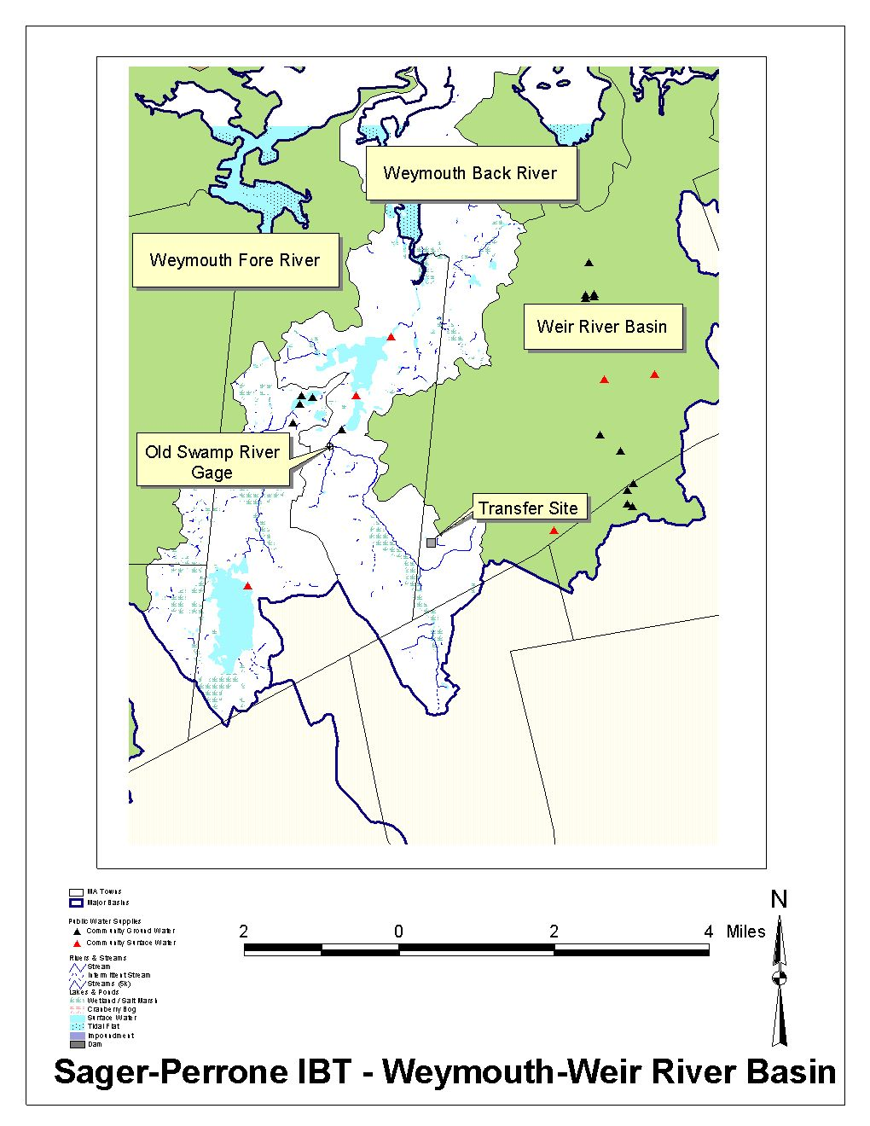

Figure 2
Special Resource Values

The Division of Marine Fisheries notes that there is an important rainbow smelt population and a river herring population within the Weymouth Back River, of which the Old Swamp River is a tributary. The Division states that the Sager-Perrone project, in itself, appears to be insignificant, however, there is concern that additional losses of water from this subbasin could cause negative cumulative impacts. The WRC raised this issue in its IBT Decision on the Weymouth Landing Area Interbasin Transfer (see Cumulative Impacts, below). The conditions in the WRC Weymouth Decision for communities wishing to transfer wastewater to the MWRA system through the Weymouth system should begin to address these concerns.

Cumulative Impacts

In July 2002, the WRC approved an application from the Town of Weymouth to construct an additional connection from the Landing area of town to the MWRA to alleviate sewer overflows caused by storm events. In its Decision, the WRC stated that there were concerns that allowing individual properties or portions of communities to connect to Weymouth’s wastewater system could lead to “segmentation” and could potentially cause unacceptable cumulative impacts.

However, at that time, the WRC specifically noted that the Sager-Perrone project was currently under Interbasin Transfer review and therefore should not be subject to the conditions for future connection of an outside community or property to the Weymouth system.

Because the flows being transferred by the Sager-Perrone project do not originate in the same subbasin of the Weymouth-Weir Basin as the transfer, and because these flows are so small, the WRC does not believe that this project will cause a significant cumulative impact when combined with the Weymouth project. In addition, Sager-Perrone has met the requirements of the Weymouth sewer bank which requires that for every one (1) gallon of wastewater allocated for a new connection, seven (7) gallons of water must be saved through the implementation of water conservation measures, I/I reduction, or the disconnection of existing sewer users.

WRC Decision

The WRC finds the proposed wastewater transfer to be insignificant, due to the following facts:

- The potential reduction in daily flows and in the 99% flow duration due to the proposed transfer are less than 5%
- The 95% flow has an insignificant reduction of 1.5%
- Flows being transferred do not originate in the same subbasin of the Weymouth-Weir Basin as the transfer
- Special resource values should not be affected.
- This project should not cause unacceptable cumulative impacts.

This Decision is contingent upon the final signed contracts and the final approved legislation containing the language in the draft contracts and the draft legislation, provided to the WRC, which stipulate that flows will not exceed 2,475 gallons per day from 60 Research Road and 2,025 gallons per day from 105 Research Road.

If flows from these properties exceed these amounts, or if the contracts are renegotiated or the legislation amended to allow for a greater quantity of wastewater flow, then the companies or their successors must apply for additional Interbasin Transfer review, with no guarantee that a higher flow value will be approved.

Executive Order 385

This Decision is consistent with EO 385, which has the dual objective of resource protection and sustainable development. The recommendation does not encourage growth without adequate infrastructure, nor does it cause an unavoidable loss of environmental quality or resources.

Attachment 1

Request for Determination of Insignificance
60 Research Road & 105 Research Road Sewer Project

Criterion | Proposal Meets | Explanation
(a) Is not over 1 mgd | Meets | Proposed increase in transfer is for a maximum of 0.0045 million gallons per day of wastewater.
(b) Is less than 1mgd on an annualized basis and is temporary, of short duration and for a purpose other than water supply use) | Not Applicable | Proposal is long-term for wastewater purposes.
(c) Additional flow is less than 5% of the instantaneous flow | Not Applicable | This transfer is less than 5% of the instantaneous flow, based on both daily 99% flow duration.
(d) The 95% exceedance flow, or the 7Q10 flow when relied in a program of pollution abatement, will not be diminished | Not Applicable | Reduction in the 95% exceedence for is insignificant (1.5%).
(e) Special resource values will not be adversely affected | Meets | Based on available information, this project will not have negative impacts on the anadromous fishery resource in the Weymouth Back River. Other special resource values were not identified.
(f) The Commission shall consider the cumulative impacts of all past, authorized or proposed transfers on streamflows in the donor basin | Meets | Flows being transferred do not originate in the same subbasin of the Weymouth-Weir Basin as the transfer.

