July 19, 2004

Janet Hutchins
Executive Office of Environmental Affairs
100 Cambridge Street
Boston MA, 02114

RE: Early Notice/ New Source Approval

The Town of Middleborough Water Department has applied to DEP for a Request for Site Exam application for siting a new public water supply source to withdraw up to approximately 0.72 mgd of water from the ground water of the Taunton River Basin, in Middleborough, MA. The location of the withdrawal point is: Latitude: 41º 56' 17.696" Longitude: 70º 58' 36.091" between Plymouth Road and the Taunton River in Middleborough, MA. Written comments on the granting of a DEP permit to conduct additional testing of the site for a new water supply withdrawal are to be filed within thirty (30) days of publication of this notice in the Environmental Monitor. The written comments are to be submitted to the Drinking Water Program Section Chief at the DEP Southeast Regional Office at 20 Riverside Drive, Lakeville, MA 02347 (508) 946-2700.

Thank you,

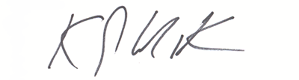

Kevin MacKinnon, P.G.
Senior Hydrogeologist
Jacques Whitford Company

