July 1, 2004 Re: FY2005 DCS Annual Grant Round

Dear Prospective Applicant:
Thank you for your interest in the FY05 Annual Grant Round for the Self-Help, Urban Self-Help and federal Land and Water Conservation Fund Programs as announced recently by Environmental Affairs Secretary Ellen Roy Herzfelder. The enclosed application package will give you a complete overview of the program you are interested in, and should be read very carefully. Your full, complete application is due in our office no later than 5 p.m. on October 1, 2004. The filing deadline you will note has been pushed back from the normal filing deadline of June 1, 2004.
Secretary Roy Herzfelder’s grant round announcement letter detailed her project funding priorities for each grant program and can be viewed at www.mass.gov/envir. Applicants should apply to the Self-Help program for conservation land acquisition projects, and to the Urban Self-Help program for parkland acquisition, improvement, or development projects. EOEA reserves the right to determine the allocation of state and federal sources of grant funds as project and budgetary conditions warrant.
The Romney Administration has launched a new incentive policy known as Commonwealth Capital to encourage municipalities to implement Smart Growth consistent land use practices. Beginning in FY05, DCS must include Smart Growth factors in the project selection systems. Municipalities must apply directly to the Office for Commonwealth Development for a Commonwealth Capital Score. The application, information and additional guidance documents are available online at http://www.mass.gov/ocd/comcap.html.

The maximum reimbursement available from the Self-Help or Urban Self-Help programs is based on your community's equalized valuation per capita decile rank and ranges from 52% to 70% of the total project cost. Federal Land and Water Conservation Fund projects may be reimbursed at up to 50%. The maximum grant award for any project has been set at $500,000, but may be raised or lowered at the discretion of the Secretary. You may not proceed with the actual land acquisition or start construction until you have obtained approval from DCS (or the National Park Service if you receive a Land and Water Conservation Fund grant) and have executed the appropriate contracts, or have obtained written permission to proceed.
To be eligible to participate in the grant round, communities must have:
- An Open Space and Recreation Plan approved by, and on file with the Division of Conservation Services; and
- No unresolved “parkland” conversion issues with the Executive Office of Environmental Affairs.
Please review the enclosed step procedures, preliminary application forms, and instructions on how to complete and prepare the required documents carefully. It is crucial to the success of your application that you work closely with DCS to determine if your community is eligible to participate, if your project fits the appropriate program requirements, and to ensure that the application is complete. Applications for acquisitions that are not accompanied by appraisals cannot be considered for funding. Be advised that all acquisition projects must be completed and closed out by June 1, 2005. Development projects, and projects funded through the Land and Water Conservation Fund may extend into FY2006.
To aid you in applying for assistance, DCS will offer a free "how-to" workshop to help you prepare a competitive preliminary application. The workshop will be held on Thursday, August 12, 2004 from 10am to 12 noon in Boston at 100 Cambridge Street. Be sure to study the enclosed information, understand the program obligations, check to determine if your community and project are eligible for assistance, and contact DCS with any questions regarding your proposal. Please RSVP for the workshop by calling DCS at (617) 626-1010. I strongly recommend that you attend a workshop if you plan to apply and look forward to working with you on your proposal.
Sincerely,
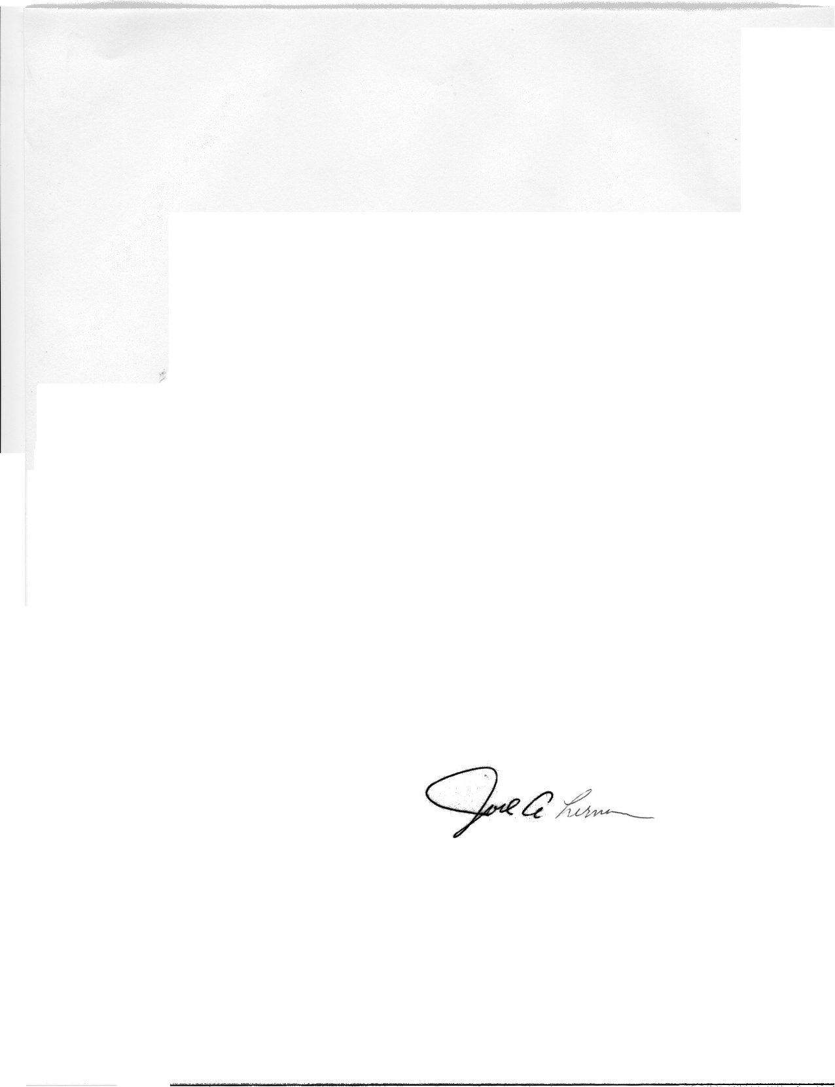

Joel A. Lerner
Director
enc. Application Package

