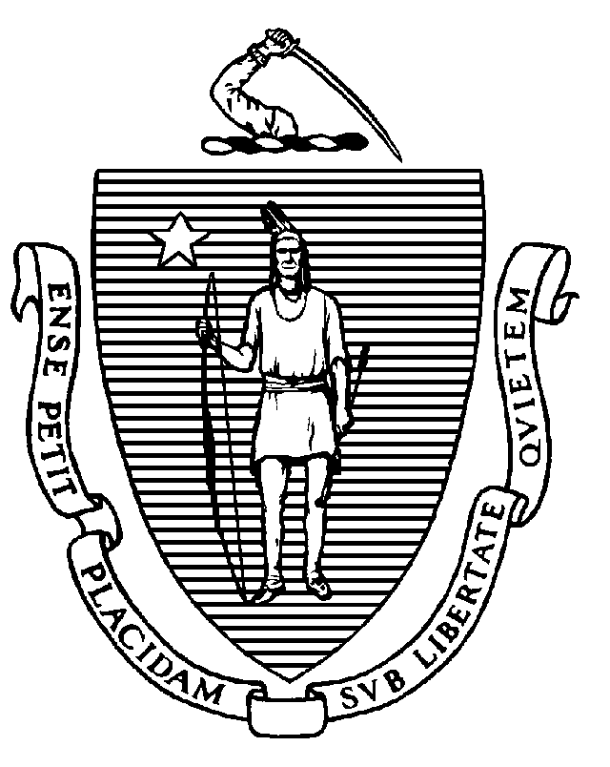
The Commonwealth of Massachusetts
office FOR commonwealth development
100 cambridge street, Suite 1010  boston, ma 02114-2524
(617) 573-1375
mitt romney
GOVERNOR
kerry healey
LIEUTENANT GOVERNOR

July 1, 2004

Dear Applicant:

We are pleased to announce a new policy, Commonwealth Capital, applying to the Executive Office of Environmental Affairs Self-Help and Urban Self-Help Programs, Clean Water and Drinking Water Revolving Funds, brownfields funding, Agriculture Preservation Restriction Program, and other land acquisition programs beginning in fiscal year 2005. Commonwealth Capital will help communities implement land-use regulations consistent with state- and region-wide sustainable development goals. This policy is another step being taken by the Office for Commonwealth Development (OCD) and the Executive Office of Environmental Affairs (EOEA) to promote compact growth and environmental protection.

All communities seeking a grant or loan from these programs will be asked to fill out a Commonwealth Capital application (attached). The application is designed to measure, as appropriate, your municipality’s efforts toward advancing sustainable development goals, and will contribute 20% to your application’s overall score.

The Governor created Commonwealth Capital to advance compact development, housing opportunities, reuse of brownfields and abandoned buildings, conservative use of land and water resources, and protection of forestry, fishing and agriculture. A maximum score of 140 points is possible, but no community is expected to meet all of the criteria; some communities will be strong in some areas and some will be strong in others. The application is crafted to acknowledge and support the differences in our communities that collectively enrich our
Commonwealth.

We made every effort to ensure the Commonwealth Capital application is clear and simple as possible. Our goal
is not to generate paper but to gain results. Guidance is available (along with the application itself), at http://www.mass.gov/ocd/comcap.html.

We are also pleased to announce that beginning this July, technical assistance will be available to help you implement sustainable development consistent land use regulations. Information will be posted at http://www.mass.gov/ocd/comcap.html as it becomes available.

For questions on Commonwealth Capital, please visit http://www.mass.gov/ocd/comcap.html or email commcap@massmail.state.ma.us or call (617) 626-4949.

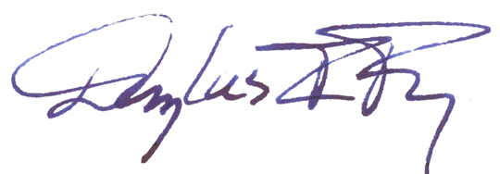
Cordially,
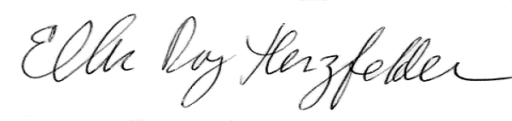

Douglas I. Foy, Secretary Ellen Roy Herzfelder, Secretary
Office for Commonwealth Development Executive Office of Environmental Affairs

