Special MWRA Reminder

Pursuant to the MEPA Regulations, Section 11.16 Filing and Circulation, Section (2) Circulation of ENF, (b) 15, a copy of an ENF must be sent to the Massachusetts Water Resources Authority (MWRA) if the project location is in a community served by MWRA sewer or water. Please refer to the list below and attached map to determine the MWRA service area. In addition, please note that if a project is proposed outside the MWRA service area and is proposing to apply for a connection to obtain MWRA water or wastewater services through an adjacent MWRA community, MWRA review of the ENF is also necessary

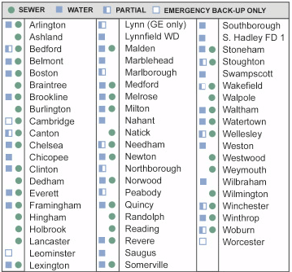
For general questions, please contact Marianne Connolly at MWRA, (617) 788-1165.

